HORTICULTURE CLASS
Site and soil assessment, soil management and fertiliser

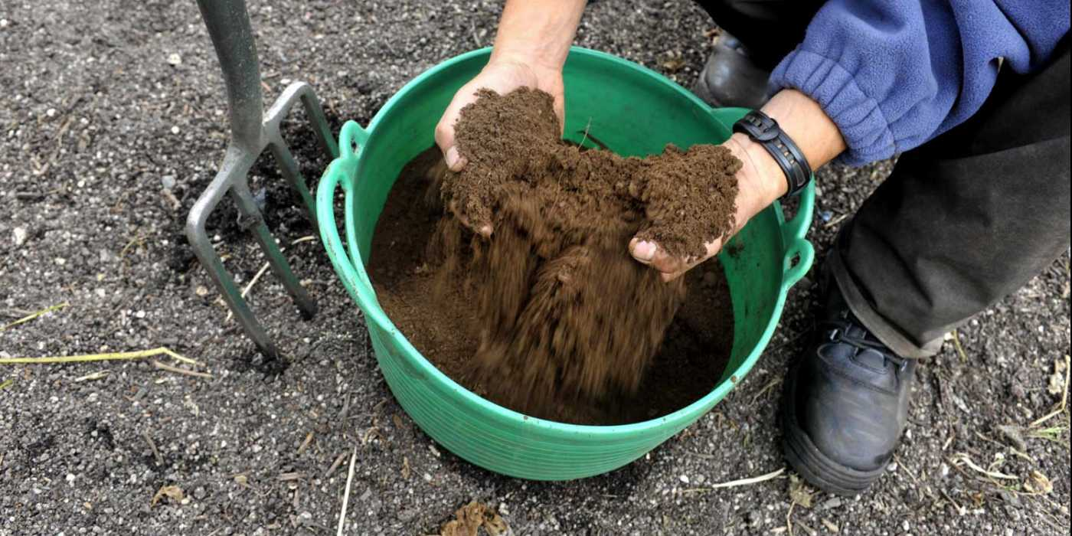
We have Audrey Litterick returning. Audrey has a vast experience in Horticulture, so you don’t want to miss this opportunity.

COST: FREE
Location: Broadford Village Hall
TIME: 9am- 5pm
DATE: Sunday 26th March

To book a place please contact Nicholas
07572655433 – nicholas@broadfordandstrath.org

